故事大纲

第一幕：Leo的早晨

Leo起床，穿好他的亮黄色T恤和工装裤，准备迎接新的一天。他看着窗外的阳光，充满活力地准备好帮助别人。小小的日常，充满了希望。

Leo wakes up, puts on his bright yellow T-shirt and overalls, and prepares for a new day. He looks out at the sunshine, feeling energetic and ready to help others. His small daily routine is filled with hope.

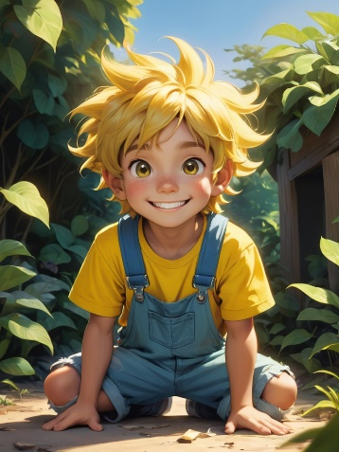 image 1 Leo的早晨

第二幕：邻居的花园

Leo走出家门，看到邻居的花园里有一些枯萎的植物。邻居看起来有点忙，Leo决定帮忙给植物浇水。

Leo steps outside and sees that the neighbor’s garden has some wilting plants. The neighbor seems busy, so Leo decides to help water the plants.

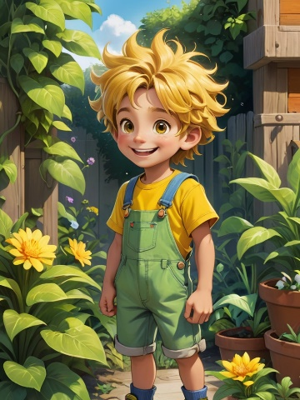 image 2邻居的花园

第三幕：小狗走丢了

Leo在公园里看到一只迷路的小狗，他决定帮助小狗找到主人。他耐心地寻找，直到终于找到了小狗的主人。

Leo sees a lost puppy in the park and decides to help it find its owner. He patiently looks around until he finally reunites the puppy with its owner.

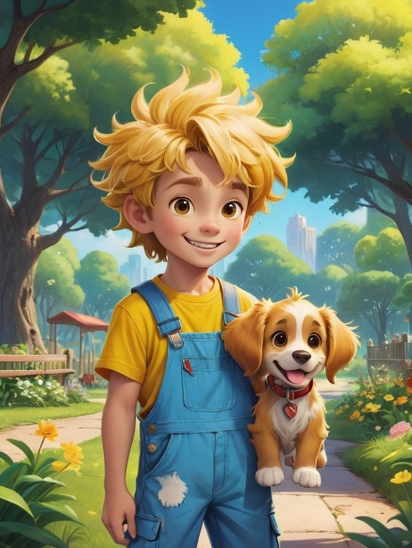 image 3 小狗走丢了

第四幕：小狗走丢了

一天，Leo看到同学没带雨伞，正在雨中淋湿。他跑回家拿了一把备用伞，递给同学，帮忙一起避雨。

One day, Leo sees a classmate without an umbrella, getting soaked in the rain. Leo runs home to grab an extra umbrella and helps his classmate stay dry.

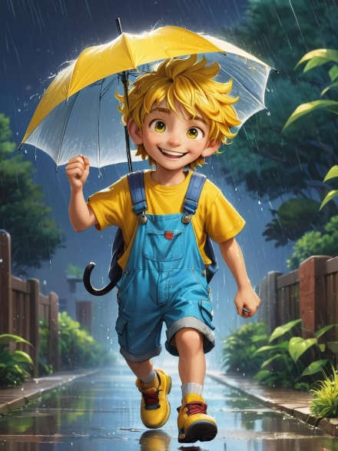 image 4小狗走丢了

第五幕：学校的清洁日

学校组织清洁活动，Leo主动参加，捡起地上的垃圾，帮助同学一起清理教室和操场。

The school organizes a cleanup event, and Leo joins in. He picks up trash and helps classmates clean the classroom and playground.

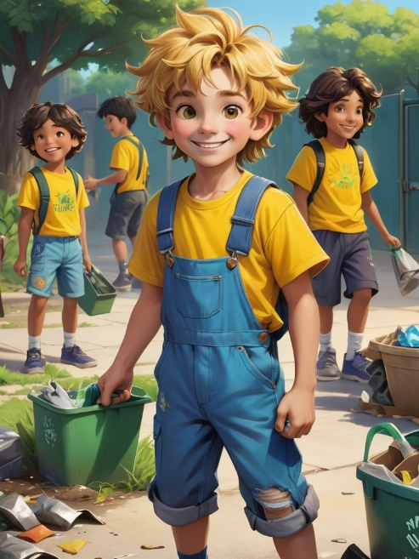 image 5学校的清洁日

第六幕：帮忙推车

Leo看到妈妈推着沉重的购物车，他主动上前帮忙一起推，虽然自己也有点吃力，但他还是坚持不懈。

Leo sees his mom struggling to push a heavy shopping cart, and he offers to help push it. Even though it’s a bit hard for him, he keeps going.

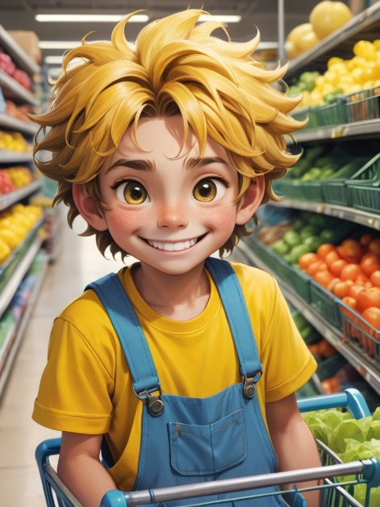image 6 帮忙推车

第七幕：帮助朋友解答难题

课后，Leo发现朋友在做作业时遇到困难，他耐心地解释给朋友听，帮助他解决问题。

After class, Leo notices his friend is having trouble with homework. Leo patiently explains the answers and helps his friend solve the problems.

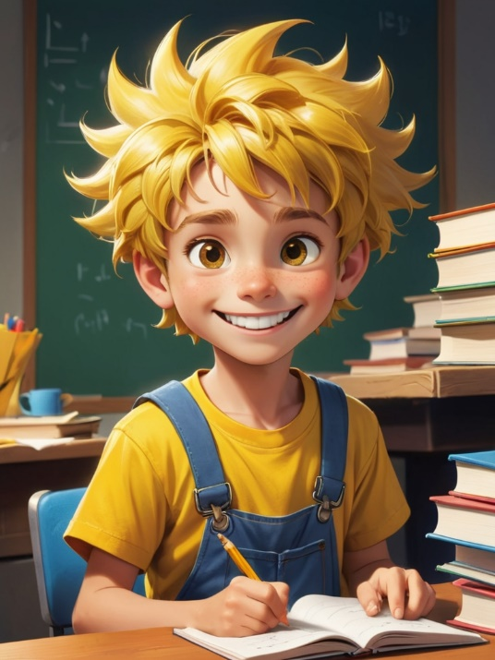 image 7 帮助朋友解答难题

第八幕：乐于分享自己的玩具

Leo和朋友们玩耍时，看到有个小朋友没有玩具，他主动把自己最喜欢的玩具借给对方。

While playing with friends, Leo notices one of them doesn’t have a toy to play with. He kindly offers to share his favorite toy with the friend.

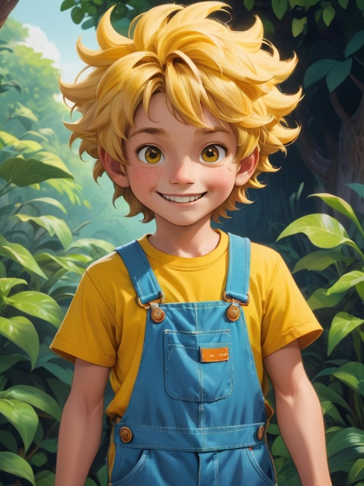 image 8 乐于分享自己的玩具

第九幕：夜晚的星空

一天晚上，Leo和爸爸妈妈一起在院子里看星星，Leo学到了很多关于星空的知识，他很高兴能与家人一起享受这份宁静。

One evening, Leo and his parents watch the stars together in the backyard. Leo learns a lot about the stars and feels happy to enjoy this peaceful moment with his family.

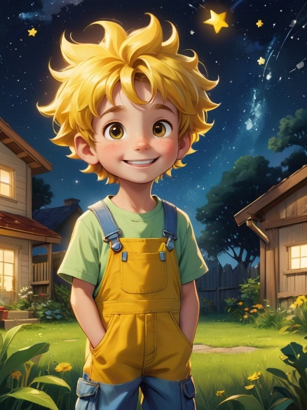 image 9 夜晚的星空

第十幕：睡前的微笑

Leo洗漱完，躺在床上，回顾自己今天做的事情，心里充满了满足感，带着微笑进入梦乡。

After brushing his teeth, Leo lies in bed and reflects on all the good things he did that day. He feels content and falls asleep with a smile on his face.

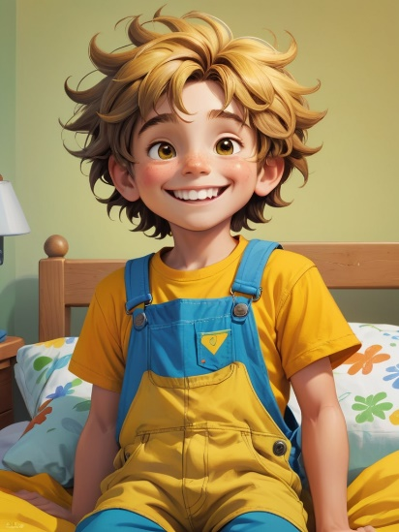image 10 睡前的微笑